**Stratification Pattern of Dissolved Oxygen and Its impact on *Scylla olivacea* in the Pasur-Rupsha Estuary of Bangladesh**

Muhammad Abdur Rouf1*, Md. Golam Sarower1, and Md Shahin Parvez1

**1**Fisheries and Marine Resource Technology Discipline, Khulna University, Khulna-9208, Bangladesh

*Email: [rouf@fmrt.ku.ac.bd](mailto:rouf@fmrt.ku.ac.bd)

Stratification pattern of dissolved oxygen (DO) and associated water parameters were measured in the head of the Pasur-Rupsha Estuary of Bangladesh. Water samples were collected from two stations at 0.60 m depth intervals during high and low tides from July, 2016 to January, 2017. DO was ranged from 6.0 to 8.6 mg/l with maximum two units of variation in the profiles of the stations and demonstrated an inconsistent stratification pattern. This stratification was remarkably triggered by a relatively high concentration of DO in the bottom layer than that of the surface layer during both the high and low tides in most of the study periods. High rate of freshwater flow in the surface; existence of estuarine gravitational circulation; and lack of consumers in the bottom due to the high deposition of sediment particles were found responsible for the relatively high concentration of DO in bottom and low in surface layer of the estuary. Temperature and plankton density were found significantly (*P*<0.000) correlated with DO while the pH and salinity did not show any significant (*P*>0.3) correlation. The results explained in this study will provide considerable advances in understanding the ecosystem dynamics of the Pasur-Rupsha Estuary of Bangladesh.

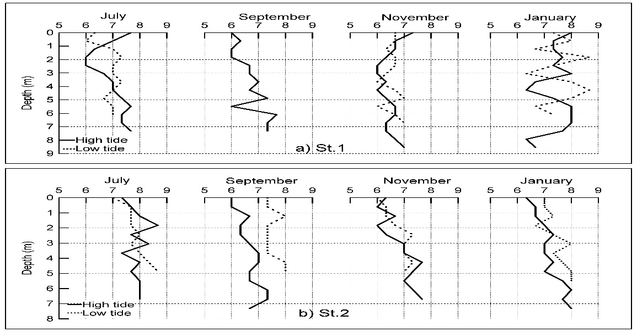Figure: Stratification pattern of DO in the Pasur-Rupsha Estuary